Aim: To perform Non-Graphical Exploratory Data Analysis.

What is Mean?
The mean (or arithmetic average) is a measure of central tendency calculated by summing all values in a dataset and dividing by the total number of values.
Formula: (Sum of values / Number of values)

What is Median?
The median is the middle value in an ordered dataset (arranged from lowest to highest), representing the 50th percentile where half the data points are below it and half are above.
- Odd Number of Data Points: The median is the exact middle number.
- Even Number of Data Points: The median is the average (mean) of the two middle numbers.

What is Mode?
The mode is the value that appears most frequently in a data set, serving as a measure of central tendency to identify the most common item or "peak" in data.
Types:
- Unimodal: One value occurs most frequently.
- Bimodal/Multimodal: Two or more values tie for the highest frequency.
- No Mode: No values repeat.

What is Standard Deviation?
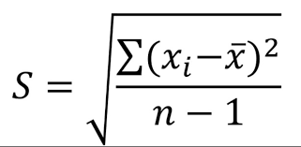
A standard deviation (or σ) is a measure of how dispersed the data is in relation to the mean. Low, or small, standard deviation indicates data are clustered tightly around the mean, and high, or large, standard deviation indicates data are more spread out.

What is Variance?
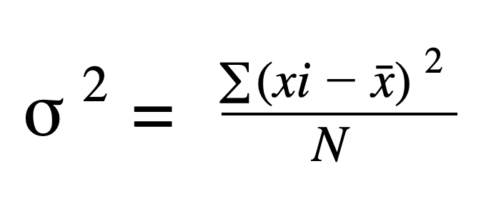
Variance is a statistical measure of how far a set of data points are spread out from their average (mean) value. Defined as the average of the squared differences from the mean, a low variance indicates data is clustered near the mean, while a high variance indicates data is widely dispersed.

What is IQR?
The Interquartile Range (IQR) is a measure of statistical dispersion that represents the spread of the middle 50% of a data set, calculated by subtracting first quartile Q1 from third Q3.
Formula: IQR = Q3 – Q1

What is Kurtosis?
Kurtosis is a statistical measure that defines the heaviness of the tails of a probability distribution relative to a normal distribution. It indicates the frequency of outliers (extreme values) in a dataset, rather than just the peak's height. High kurtosis means more, extreme outliers, while low kurtosis indicates fewer, lighter outliers.
Types of Kurtosis:
- Leptokurtic (High Kurtosis): Sharp peak, heavy tails, high outlier risk.
- Mesokurtic (Normal Kurtosis): Moderate, normal distribution shape.
- Platykurtic (Low Kurtosis): Flat peak, thin tails, low outlier risk.

Dataset:
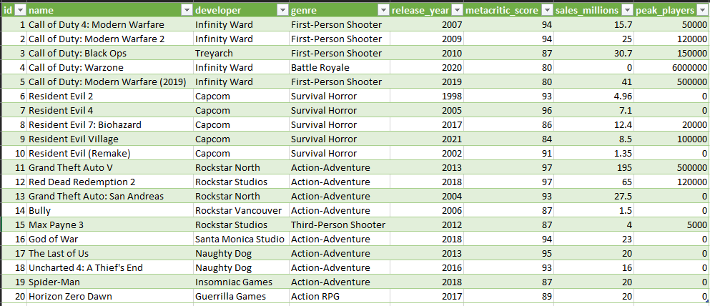

Code:
import pandas as pd

df = pd.DataFrame(dataset)

print()
print("=" * 122)
print(f"{'ID':<4} {'Name':<35} {'Developer':<20} {'Genre':<18} {'Year':<6} {'Metacritic':<10} {'Sales (M)':<10} {'Peak Players':<12}")
print("-" * 122)

for game in dataset:
print(f"{game['id']:<4} {game['name'][:34]:<35} {game['developer'][:19]:<20} {game['genre'][:17]:<18} "
f"{game['release_year']:<6} {game['metacritic_score']:<10} {game['sales_millions']:<10.1f} {game['peak_players']:<12,}")

print("=" * 122)

mean_metacritic_score = df["metacritic_score"].mean()
mean_sales = df["sales_millions"].mean()
mean_peak_players = df["peak_players"].mean()

print(f"\nAverage Metacritic Score: {mean_metacritic_score:.2f}")
print(f"Average Sales (Millions): {mean_sales:.2f}")
print(f"Average Peak Players: {mean_peak_players:.2f}")

median_metacritic_score = df["metacritic_score"].median()
median_sales = df["sales_millions"].median()

print(f"\nMedian Metacritic Score: {median_metacritic_score:.2f}")
print(f"Median Sales (Millions): {median_sales:.2f}")

mode_metacritic_score = df["metacritic_score"].mode()[0]
mode_sales = df["sales_millions"].mode()[0]

print(f"\nMode Metacritic Score: {mode_metacritic_score:.2f}")
print(f"Mode Sales (Millions): {mode_sales:.2f}")

std_metacritic_score = df["metacritic_score"].std()
std_sales = df["sales_millions"].std()

print(f"\nStandard Deviation of Metacritic Score: {std_metacritic_score:.2f}")
print(f"Standard Deviation of Sales (Millions): {std_sales:.2f}")

variance_metacritic_score = df["metacritic_score"].var()
variance_sales = df["sales_millions"].var()

print(f"\nVariance of Metacritic Score: {variance_metacritic_score:.2f}")
print(f"Variance of Sales (Millions): {variance_sales:.2f}")

quartile1_metacritic_score = df["metacritic_score"].quantile(0.25)
quartile3_metacritic_score = df["metacritic_score"].quantile(0.75)

print(f"\n1st Quartile of Metacritic Score: {quartile1_metacritic_score:.2f}")
print(f"3rd Quartile of Metacritic Score: {quartile3_metacritic_score:.2f}")

kurtosis_metacritic_score = df["metacritic_score"].kurtosis()
kurtosis_sales = df["sales_millions"].kurtosis()

print(f"\nKurtosis of Metacritic Score: {kurtosis_metacritic_score:.2f}")
print(f"Kurtosis of Sales (Millions): {kurtosis_sales:.2f}")

Output:
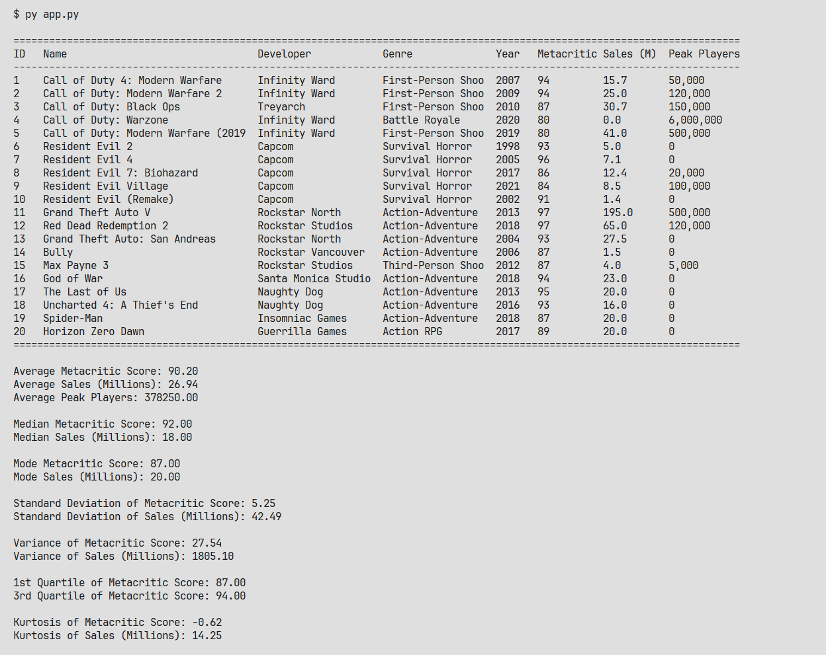

Conclusion
Successfully demonstrated non-graphical data analysis using pandas for the given dataset.

skewness_metacritic_score = df["metacritic_score"].skew()
skewness_sales = df["sales_millions"].skew()

print(f"\nSkewness of Metacritic Score: {skewness_metacritic_score:.2f}")
print(f"Skewness of Sales (Millions): {skewness_sales:.2f}")

if abs(skewness_metacritic_score) < 0.5:
print(f"\nMetacritic Score: Approximately symmetric (skewness = {skewness_metacritic_score:.2f})")
elif skewness_metacritic_score < 0:
print(f"Metacritic Score: Negatively skewed (left-skewed) = {skewness_metacritic_score:.2f}")
else:
print(f"Metacritic Score: Positively skewed (right-skewed) = {skewness_metacritic_score:.2f}")

if abs(skewness_sales) < 0.5:
print(f"Sales: Approximately symmetric (skewness = {skewness_sales:.2f})")
elif skewness_sales < 0:
print(f"Sales: Negatively skewed (left-skewed) = {skewness_sales:.2f}")
else:
print(f"Sales: Positively skewed (right-skewed) = {skewness_sales:.2f}")

